Locus of Points on a Fixed Circle

Definition
# Source: AI Source: Provided by: [Data Path: Persons Table -> ID Column: 1, Name_En Column: Motasem Essam] -> From: [ChatGPT] on [7/25/2026]
The locus of points on a fixed circle is the set of all points that lie on a given fixed circle.
If a circle with center $O$and radius $r$is fixed, then a point $P$belongs to the locus exactly when
$$\boxed{P∈C}$$
or, equivalently,
$$\boxed{OP=r}$$
where:
- $O$= fixed center
- $r$= fixed radius
- $P$= variable point on the circle
- $C$= fixed circle
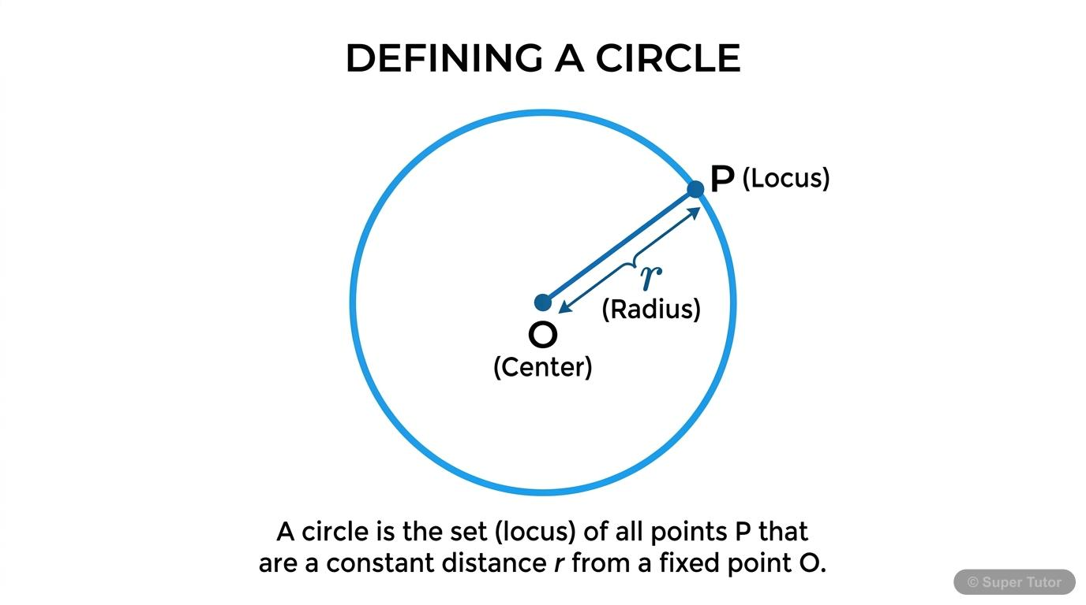
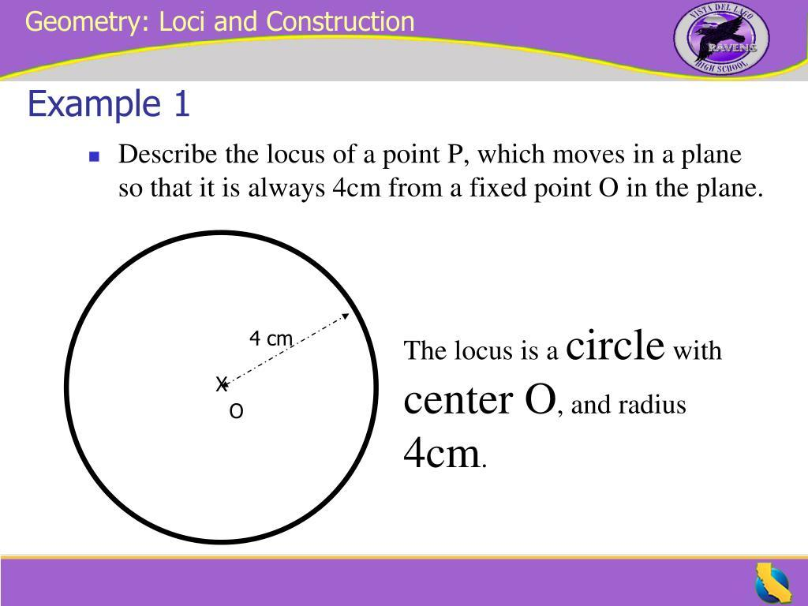
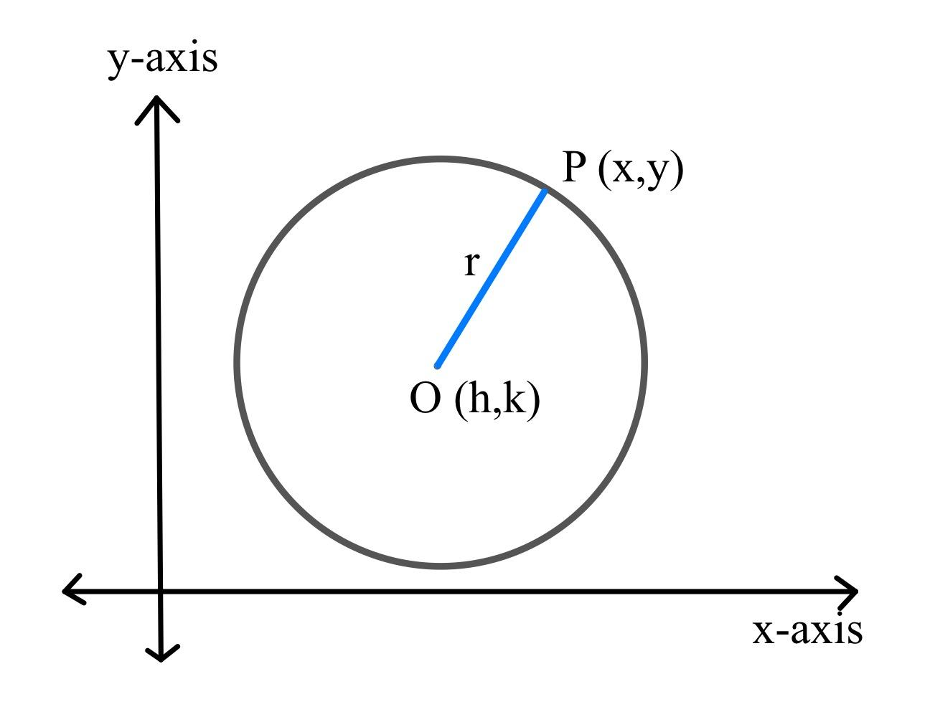
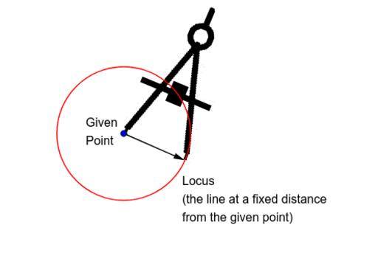
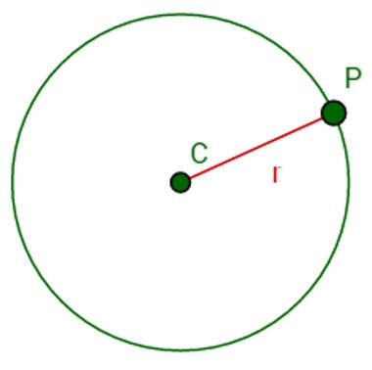
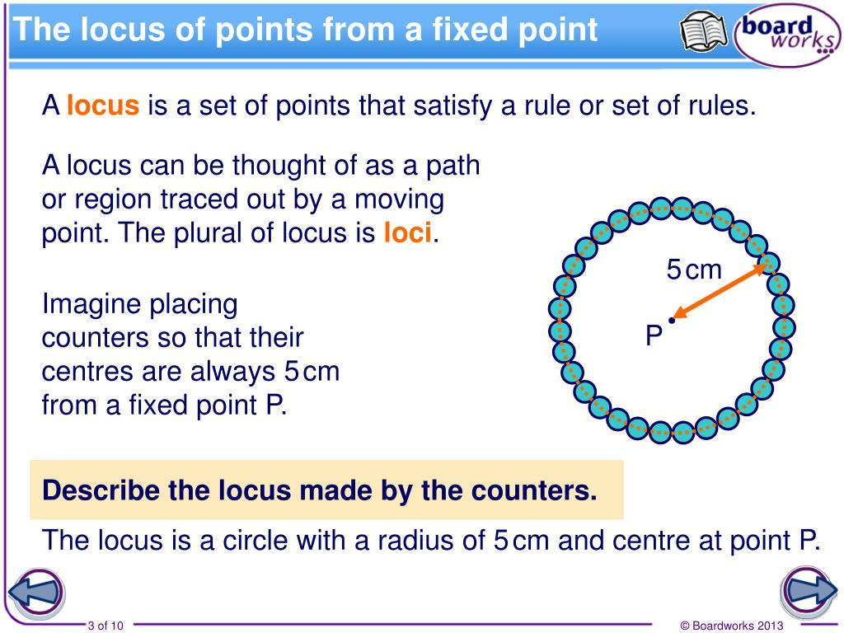

Simple Definition
# Source: AI Source: Provided by: [Data Path: Persons Table -> ID Column: 1, Name_En Column: Motasem Essam] -> From: [ChatGPT] on [7/25/2026]
The locus of points on a fixed circle is the entire circumference of that circle.
For example, if $O$is the center of a circle with radius $5$cm, every point $P$on the circle satisfies
$$OP=5\text{ cm}.$$
Therefore, all such points form the fixed circle.

Fundamental Concept
# Source: AI Source: Provided by: [Data Path: Persons Table -> ID Column: 1, Name_En Column: Motasem Essam] -> From: [ChatGPT] on [7/25/2026]
A fixed circle is determined by:
- A fixed center $O$
- A fixed radius $r$
The locus condition is:
$$\boxed{OP=r}$$
Therefore:
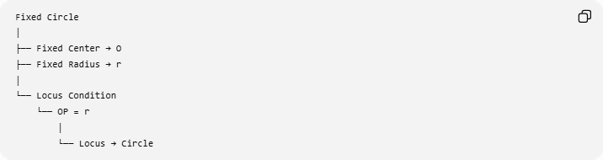
Fixed Circle
│
├── Fixed Center → O
├── Fixed Radius → r
│
└── Locus Condition
└── OP = r
│
└── Locus → Circle
Every point satisfying $OP=r$lies on the circle, and every point on the circle satisfies $OP=r$.
Thus:
$$\boxed{P\text{ lies on the circle }⟺ OP=r}$$

Geometric Meaning
# Source: AI Source: Provided by: [Data Path: Persons Table -> ID Column: 1, Name_En Column: Motasem Essam] -> From: [ChatGPT] on [7/25/2026]
Suppose $O$is fixed and $r=4$.
Any point $P$satisfying
$$OP=4$$
must be exactly $4$units from $O$.
There are infinitely many possible positions for $P$, but all of them form one circle.
For example:
$$PA=PB=PC=PD=4$$
if $A,B,C,D$are points on the same circle centered at $P$.
The important idea is:
$$\boxed{\text{Fixed Point}+\text{Fixed Distance}→\text{Circle}}$$

Coordinate Representation
# Source: AI Source: Provided by: [Data Path: Persons Table -> ID Column: 1, Name_En Column: Motasem Essam] -> From: [ChatGPT] on [7/25/2026]
Suppose the fixed circle has center
$$O=\left(h , k\right)$$
and radius $r$.
For a variable point
$$P=\left(x , y\right),$$
the distance from $P$to $O$is
$$OP=\sqrt{{\left(x-h\right)}^{2}+{\left(y-k\right)}^{2}}.$$
The locus condition is
$$OP=r.$$
Therefore,
$$\sqrt{{\left(x-h\right)}^{2}+{\left(y-k\right)}^{2}}=r.$$
Squaring both sides:
$$\boxed{{\left(x-h\right)}^{2}+{\left(y-k\right)}^{2}=r^{2}}$$
This is the standard equation of the fixed circle.

Circle Centered at the Origin
# Source: AI Source: Provided by: [Data Path: Persons Table -> ID Column: 1, Name_En Column: Motasem Essam] -> From: [ChatGPT] on [7/25/2026]
If the center is
$$O=\left(0 , 0\right),$$
then
$$h=0, k=0.$$
Therefore:
$$\boxed{x^{2}+y^{2}=r^{2}}$$
For example, if $r=5$:
$$\boxed{x^{2}+y^{2}=25}$$
is the locus of all points $P=\left(x , y\right)$that are exactly $5$units from the origin.

Example 1 — Fixed Circle at the Origin
# Source: AI Source: Provided by: [Data Path: Persons Table -> ID Column: 1, Name_En Column: Motasem Essam] -> From: [ChatGPT] on [7/25/2026]
Suppose the fixed center is
$$O=\left(0 , 0\right)$$
and the fixed radius is
$$r=3.$$
The locus condition is
$$OP=3.$$
Therefore:
$$\boxed{x^{2}+y^{2}=9}$$
Some points on the locus are:
$$\left(3 , 0\right), \left(- , 30\right), \left(0 , 3\right), \left(0 , -3\right).$$
Each is exactly $3$units from the origin.

Example 2 — Circle with a Non-Origin Center
# Source: AI Source: Provided by: [Data Path: Persons Table -> ID Column: 1, Name_En Column: Motasem Essam] -> From: [ChatGPT] on [7/25/2026]
Suppose the fixed circle has center
$$O=\left(2 , 3\right)$$
and radius
$$r=4.$$
The locus condition is
$$OP=4.$$
Therefore:
$$\boxed{{\left(x-2\right)}^{2}+{\left(y-3\right)}^{2}=16}$$
Every point satisfying this equation lies on the fixed circle.
For example,
$$P=\left(6 , 3\right)$$
gives
$${\left(6-2\right)}^{2}+{\left(3-3\right)}^{2}=16,$$
so
$$OP=4.$$
Therefore $P$lies on the circle.

Example 3 — Testing Whether a Point Is on the Circle
# Source: AI Source: Provided by: [Data Path: Persons Table -> ID Column: 1, Name_En Column: Motasem Essam] -> From: [ChatGPT] on [7/25/2026]
Suppose the fixed circle is
$${\left(x-1\right)}^{2}+{\left(y+2\right)}^{2}=25.$$
Its center is
$$O=\left(1 , -2\right)$$
and radius is
$$r=5.$$
Test
$$P=\left(4 , 2\right).$$
Calculate:
$$OP=\sqrt{{\left(4-1\right)}^{2}+{\left(2+2\right)}^{2}} \\ =\sqrt{3^{2}+4^{2}} \\ =\sqrt{25} \\ =5.$$
Since
$$OP=r,$$
the point lies on the locus.
$$\boxed{P\text{ is on the circle}}$$

Example 4 — A Point Not on the Locus
# Source: AI Source: Provided by: [Data Path: Persons Table -> ID Column: 1, Name_En Column: Motasem Essam] -> From: [ChatGPT] on [7/25/2026]
Using the same circle,
$${\left(x-1\right)}^{2}+{\left(y+2\right)}^{2}=25,$$
consider
$$P=\left(5 , 2\right).$$
Then
$$OP=\sqrt{{\left(5-1\right)}^{2}+{\left(2+2\right)}^{2}} \\ =\sqrt{16+16} \\ =\sqrt{32}.$$
Since
$$\sqrt{32}>5,$$
the point is outside the circle.
Therefore:
$$\boxed{P∉\text{locus}}$$

Relationship with Interior and Exterior Loci
# Source: AI Source: Provided by: [Data Path: Persons Table -> ID Column: 1, Name_En Column: Motasem Essam] -> From: [ChatGPT] on [7/25/2026]
The condition determines whether the point is on, inside, or outside the circle.
On the circle
$$\boxed{OP=r}$$
This gives the circle itself.
Inside the circle
$$\boxed{OP<r}$$
This gives the interior of the circle.
Inside or on the circle
$$\boxed{OP≤r}$$
This gives the closed disk.
Outside the circle
$$\boxed{OP>r}$$
This gives the exterior region.
Outside or on the circle
$$\boxed{OP≥r}$$
Thus:
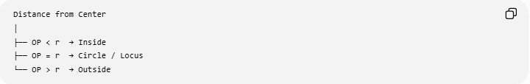
Distance from Center
│
├── OP < r → Inside
├── OP = r → Circle / Locus
└── OP > r → Outside
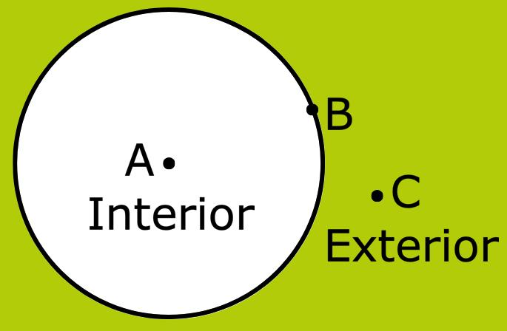
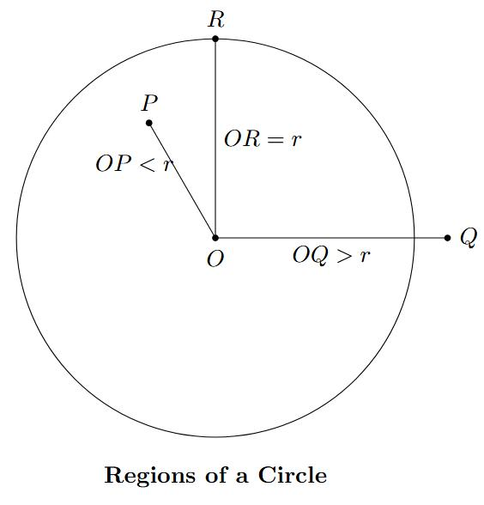
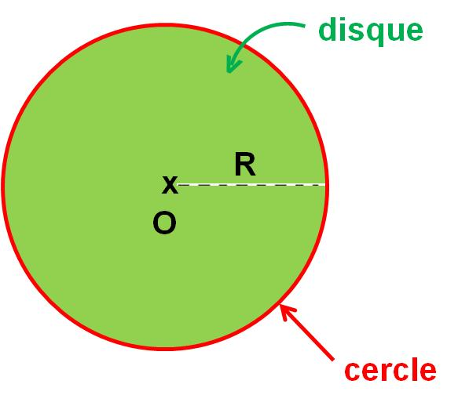
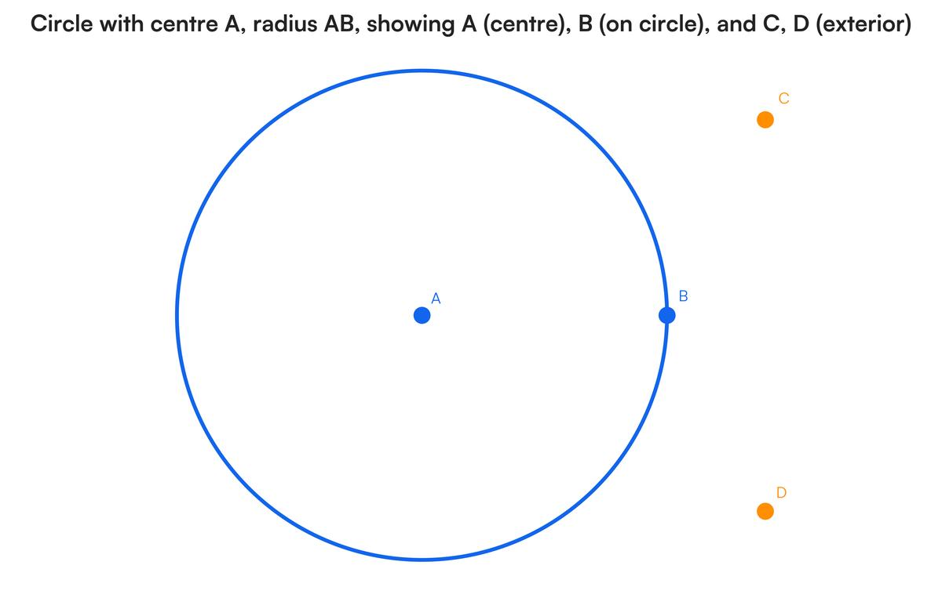

Fixed Circle as a Locus
# Source: AI Source: Provided by: [Data Path: Persons Table -> ID Column: 1, Name_En Column: Motasem Essam] -> From: [ChatGPT] on [7/25/2026]
The circle can itself be described as a locus:
$$\boxed{C=\left\{P:OP=r\right\}}$$
This means:
$C$is the set of all points $P$whose distance from $O$is exactly $r$.
This is one of the most fundamental examples of a locus in Euclidean geometry.

Construction Interpretation
# Source: AI Source: Provided by: [Data Path: Persons Table -> ID Column: 1, Name_En Column: Motasem Essam] -> From: [ChatGPT] on [7/25/2026]
A fixed circle can be constructed using a compass.
Given:
- fixed point $O$
- fixed distance $r$
Procedure:
- Place the compass point at $O$.
- Set the compass opening to $r$.
- Rotate the compass around $O$.
- The resulting curve contains every point exactly $r$from $O$.
Therefore:
$$\boxed{\text{Compass construction}→\text{Fixed-distance locus}}$$

Fixed Circle and Moving Point
# Source: AI Source: Provided by: [Data Path: Persons Table -> ID Column: 1, Name_En Column: Motasem Essam] -> From: [ChatGPT] on [7/25/2026]
Suppose $P$moves continuously around a fixed circle.
Although the position of $P$changes, its distance from the center remains constant:
$$OP=r.$$
Therefore:
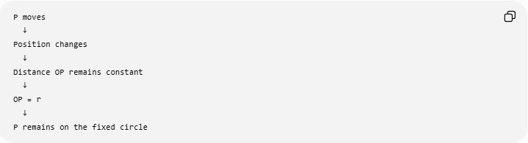
P moves
↓
Position changes
↓
Distance OP remains constant
↓
OP = r
↓
P remains on the fixed circle
This is why a circle is naturally described as a locus.

Relationship with Other Loci
# Source: AI Source: Provided by: [Data Path: Persons Table -> ID Column: 1, Name_En Column: Motasem Essam] -> From: [ChatGPT] on [7/25/2026]
The fixed-circle locus belongs to the broader family of fixed-distance loci.
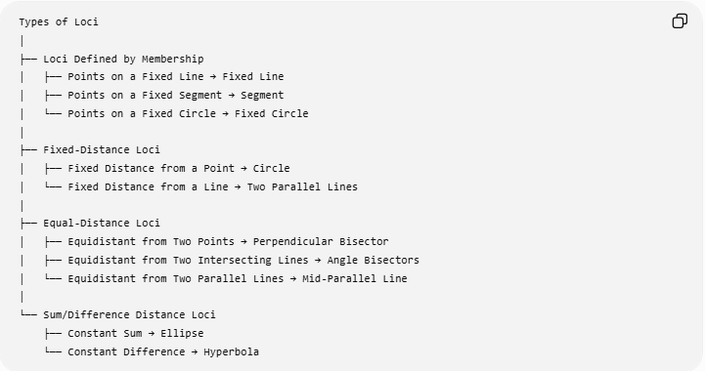
Types of Loci
│
├── Loci Defined by Membership
│ ├── Points on a Fixed Line → Fixed Line
│ ├── Points on a Fixed Segment → Segment
│ └── Points on a Fixed Circle → Fixed Circle
│
├── Fixed-Distance Loci
│ ├── Fixed Distance from a Point → Circle
│ └── Fixed Distance from a Line → Two Parallel Lines
│
├── Equal-Distance Loci
│ ├── Equidistant from Two Points → Perpendicular Bisector
│ ├── Equidistant from Two Intersecting Lines → Angle Bisectors
│ └── Equidistant from Two Parallel Lines → Mid-Parallel Line
│
└── Sum/Difference Distance Loci
├── Constant Sum → Ellipse
└── Constant Difference → Hyperbola
There is an important distinction between:
$$\boxed{\text{Points on a Fixed Circle}}$$
and
$$\boxed{\text{Points at a Fixed Distance from a Point}}.$$
They describe the same geometric set when the fixed point is the circle's center and the fixed distance is its radius.

Fixed Circle vs Fixed Distance from a Point
# Source: AI Source: Provided by: [Data Path: Persons Table -> ID Column: 1, Name_En Column: Motasem Essam] -> From: [ChatGPT] on [7/25/2026]
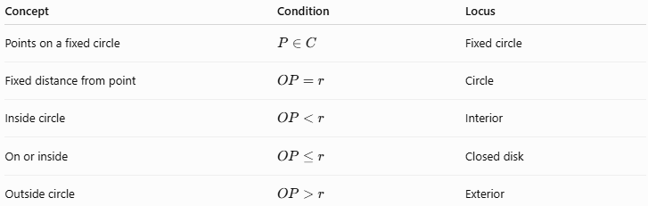
Concept | Condition | Locus
Points on a fixed circle | $$P∈C$$ | Fixed circle
Fixed distance from point | $$OP=r$$ | Circle
Inside circle | $$OP<r$$ | Interior
On or inside | $$OP≤r$$ | Closed disk
Outside circle | $$OP>r$$ | Exterior
Therefore:
$$\boxed{P∈C ⟺ OP=r}$$
when $C$has center $O$and radius $r$.

Special Cases

1-Fixed Circle Centered at the Origin
# Source: AI Source: Provided by: [Data Path: Persons Table -> ID Column: 1, Name_En Column: Motasem Essam] -> From: [ChatGPT] on [7/25/2026]
$$\boxed{x^{2}+y^{2}=r^{2}}$$

2-Fixed Circle with Arbitrary Center
# Source: AI Source: Provided by: [Data Path: Persons Table -> ID Column: 1, Name_En Column: Motasem Essam] -> From: [ChatGPT] on [7/25/2026]
$$\boxed{{\left(x-h\right)}^{2}+{\left(y-k\right)}^{2}=r^{2}}$$

3-Unit Circle
# Source: AI Source: Provided by: [Data Path: Persons Table -> ID Column: 1, Name_En Column: Motasem Essam] -> From: [ChatGPT] on [7/25/2026]
If
$$r=1,$$
then:
$$\boxed{x^{2}+y^{2}=1}$$
This is the unit circle.

4-Circle of Radius Zero
# Source: AI Source: Provided by: [Data Path: Persons Table -> ID Column: 1, Name_En Column: Motasem Essam] -> From: [ChatGPT] on [7/25/2026]
If
$$r=0,$$
then:
$$OP=0,$$
so $P=O$.
Thus the locus degenerates to a single point rather than a nondegenerate circle.

Higher-Dimensional Analogy
# Source: AI Source: Provided by: [Data Path: Persons Table -> ID Column: 1, Name_En Column: Motasem Essam] -> From: [ChatGPT] on [7/25/2026]
The same locus principle extends to higher dimensions.
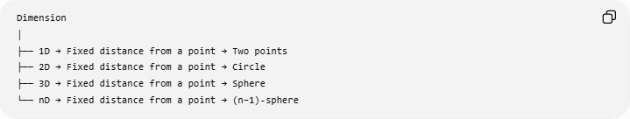
Dimension
│
├── 1D → Fixed distance from a point → Two points
├── 2D → Fixed distance from a point → Circle
├── 3D → Fixed distance from a point → Sphere
└── nD → Fixed distance from a point → (n−1)-sphere
In 3D, if $O=\left(h , k , l\right)$:
$$\boxed{{\left(x-h\right)}^{2}+{\left(y-k\right)}^{2}+{\left(z-l\right)}^{2}=r^{2}}$$
This produces a sphere.

Important Distinction: Circle vs Disk
# Source: AI Source: Provided by: [Data Path: Persons Table -> ID Column: 1, Name_En Column: Motasem Essam] -> From: [ChatGPT] on [7/25/2026]
A circle is the boundary:
$$\boxed{OP=r}$$
A disk is the region enclosed by the circle:
$$\boxed{OP≤r}$$
Therefore:
$$\boxed{\text{Circle}≠\text{Disk}}$$
in precise geometric terminology.
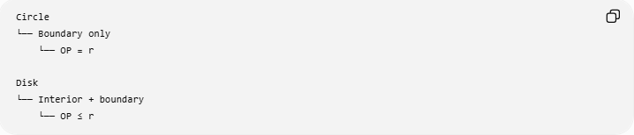
Circle
└── Boundary only
└── OP = r

Disk
└── Interior + boundary
└── OP ≤ r

Key Properties
# Source: AI Source: Provided by: [Data Path: Persons Table -> ID Column: 1, Name_En Column: Motasem Essam] -> From: [ChatGPT] on [7/25/2026]
For a fixed circle with center $O$and radius $r$:
- Every point on the circle is exactly $r$from $O$.
- The center is fixed.
- The radius is fixed.
- The circumference is the locus.
- There are infinitely many points on the locus.
- The locus is closed and bounded.
- In the Euclidean plane, the locus is one-dimensional.
- Its coordinate equation is
$${\left(x-h\right)}^{2}+{\left(y-k\right)}^{2}=r^{2}.$$
- The circle is the boundary of the corresponding disk.
- A compass can construct this locus from its center and radius.

Classification Summary
# Source: AI Source: Provided by: [Data Path: Persons Table -> ID Column: 1, Name_En Column: Motasem Essam] -> From: [ChatGPT] on [7/25/2026]
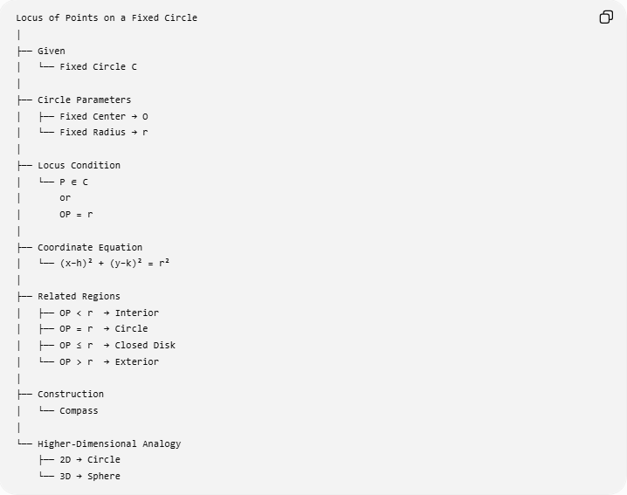
Locus of Points on a Fixed Circle
│
├── Given
│ └── Fixed Circle C
│
├── Circle Parameters
│ ├── Fixed Center → O
│ └── Fixed Radius → r
│
├── Locus Condition
│ └── P ∈ C
│ or
│ OP = r
│
├── Coordinate Equation
│ └── (x−h)² + (y−k)² = r²
│
├── Related Regions
│ ├── OP < r → Interior
│ ├── OP = r → Circle
│ ├── OP ≤ r → Closed Disk
│ └── OP > r → Exterior
│
├── Construction
│ └── Compass
│
└── Higher-Dimensional Analogy
├── 2D → Circle
└── 3D → Sphere

Key Formula
# Source: AI Source: Provided by: [Data Path: Persons Table -> ID Column: 1, Name_En Column: Motasem Essam] -> From: [ChatGPT] on [7/25/2026]
$$\boxed{P\text{ lies on a fixed circle }⟺ OP=r}$$
and, in Cartesian coordinates,
$$\boxed{{\left(x-h\right)}^{2}+{\left(y-k\right)}^{2}=r^{2}}$$

Conclusion
# Source: AI Source: Provided by: [Data Path: Persons Table -> ID Column: 1, Name_En Column: Motasem Essam] -> From: [ChatGPT] on [7/25/2026]
The locus of points on a fixed circle is the set of all points belonging to that circle. If the circle has fixed center $O$and radius $r$, its defining condition is
$$\boxed{OP=r}.$$
This makes the fixed circle one of the most fundamental examples of a geometric locus: a fixed point together with a fixed distance produces a circle in the plane.

